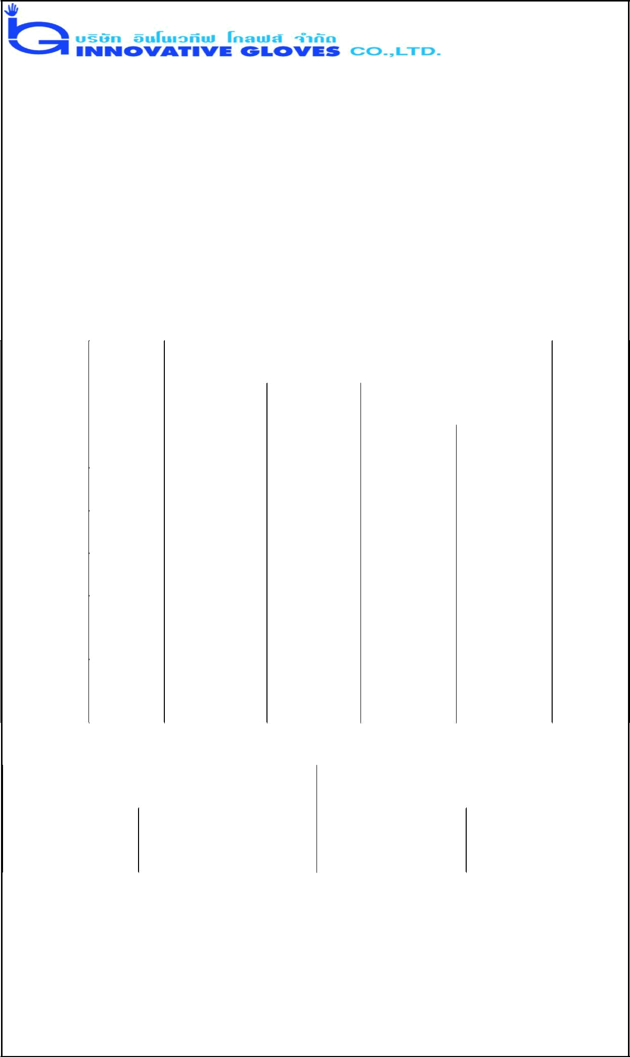

PRODUCT SPECIFICATION

 | Name of Product |  |  |  |  | : 14.0 Mil Powder Free Latex House Hold Gloves.
 | Name of Manufacturer : Innovative Gloves Co. Ltd. Hatyai, Thailand
 | Base Material |  |  |  |  | : Natural Latex
 | Characteristics |  |  |  |  | : Non Sterile, Ambidextrous Beaded Cuff
 | Available Sizes |  |  |  |  | : Small, Medium, Large, X-Large, XX- Large
 | Surface |  |  |  |  | : Diamond Textured.
 | Surface Treatment |  |  |  |  | : Mild washing with chlorine solution and extensive
 | Colour |  |  |  |  | Washing.
 | Colour |  |  |  |  | : Blue and White.
 | Physical Specifications:
 |  | Length |  |  |  | SINGLE WALL THICKNESS (mm) |  |  |  |  |  |  |  |  |  | Width
 | Size |  |  |  |  | Cuff |  | Palm |  |  | Tip |  |  |  |  | Width
 | Size | (mm) |  |  |  | Cuff |  |  |  |  |  |  |  |  |  | (mm)
 |  |  |  |  |  | Smooth |  | Textured |  |  | Smooth |  | Textured
 |  |  |  |  |  | Surface |  | Surface |  |  | Surface |  | Surface
 | Small | 300±10 |  |  |  | 0.21+0.01 |  | 0.65±0.05 |  |  | 0.37±0.01 |  | 0.60±0.05 |  |  | 95±5
 | (7) |  |  |  |  | 0.21+0.01 |  |  |  |  | 0.37±0.01 |  |  |  |  | 95±5
 | Medium | 300±10 |  |  |  | 0.21+0.01 |  | 0.65±0.05 |  |  | 0.37±0.01 |  | 0.60±0.05 |  |  | 105±5
 | (8) |  |  |  |  | 0.21+0.01 |  |  |  |  | 0.37±0.01 |  |  |  |  | 105±5
 | Large | 300±10 |  |  |  | 0.21+0.01 |  | 0.65±0.05 |  |  | 0.37±0.01 |  | 0.60±0.05 |  |  | 115±5
 | (9) |  |  |  |  | 0.21+0.01 |  |  |  |  | 0.37±0.01 |  |  |  |  | 115±5
 | X-Large | 300±10 |  |  |  | 0.21+0.01 |  | 0.65±0.05 |  |  | 0.37±0.01 |  | 0.60±0.05 |  |  | 120±3
 | (10)
 | X X-
 | Large | 300±10 |  |  |  | 0.21+0.01 |  | 0.65±0.05 |  |  | 0.37±0.01 |  | 0.60±0.05 |  |  | 125±3
 | (11)
 | Physical Properties:
 |  | Before Aging |  |  |  |  |  |  |  |  | After Accelerated Aging
 | Tensile |  |  | Ultimate Elongation |  |  |  |  |  | Tensile Strength |  |  | Ultimate
 | Strength |  |  |  |  |  |  |  |  |  |  |  | Elongation
 | 21 Mpa. Min. |  |  | 700% Min. |  |  |  |  |  | 18 Mpa. Min. |  |  | 500% Min
 | Total Residue Content |  |  |  |  |  |  | <= 2.0 Milligrams per glove
 | Packaging (Normal) |  |  |  |  |  |  | - 50 pieces in one Dispenser Box/Poly Bag
 |  |  |  |  |  |  |  | 10 Dispenser Box / Poly Bag in one Carton
 | Labeling on Dispenser (Normal) - Product Name, Size, Lot no. Quantity,
 |  |  |  |  |  |  |  | Manufacturer’s address
 | Labeling on Carton (Normal) |  |  |  |  |  |  | - Product Name, Size, Lot no. Quantity,
 |  |  |  |  |  |  |  | Country of Origin

